Launch an Instance in a Placement Group



This section will guide you to:

* Launch an instance in a placement group

This lab has two subsections, namely:

4.3.1 Creating a placement group

4.3.2 Launching an instance in the placement group

**Step 4.3.1:** Creating a placement group

* Click on *Create Placement Group*

# 

* Provide a name and strategy

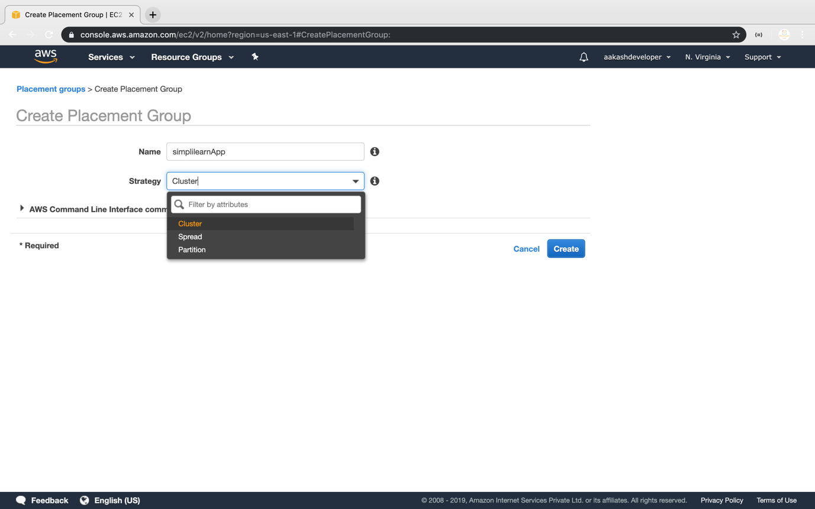

**Step 4.3.2:** Launching an instance in the placement group

* Launch the new EC2 instance

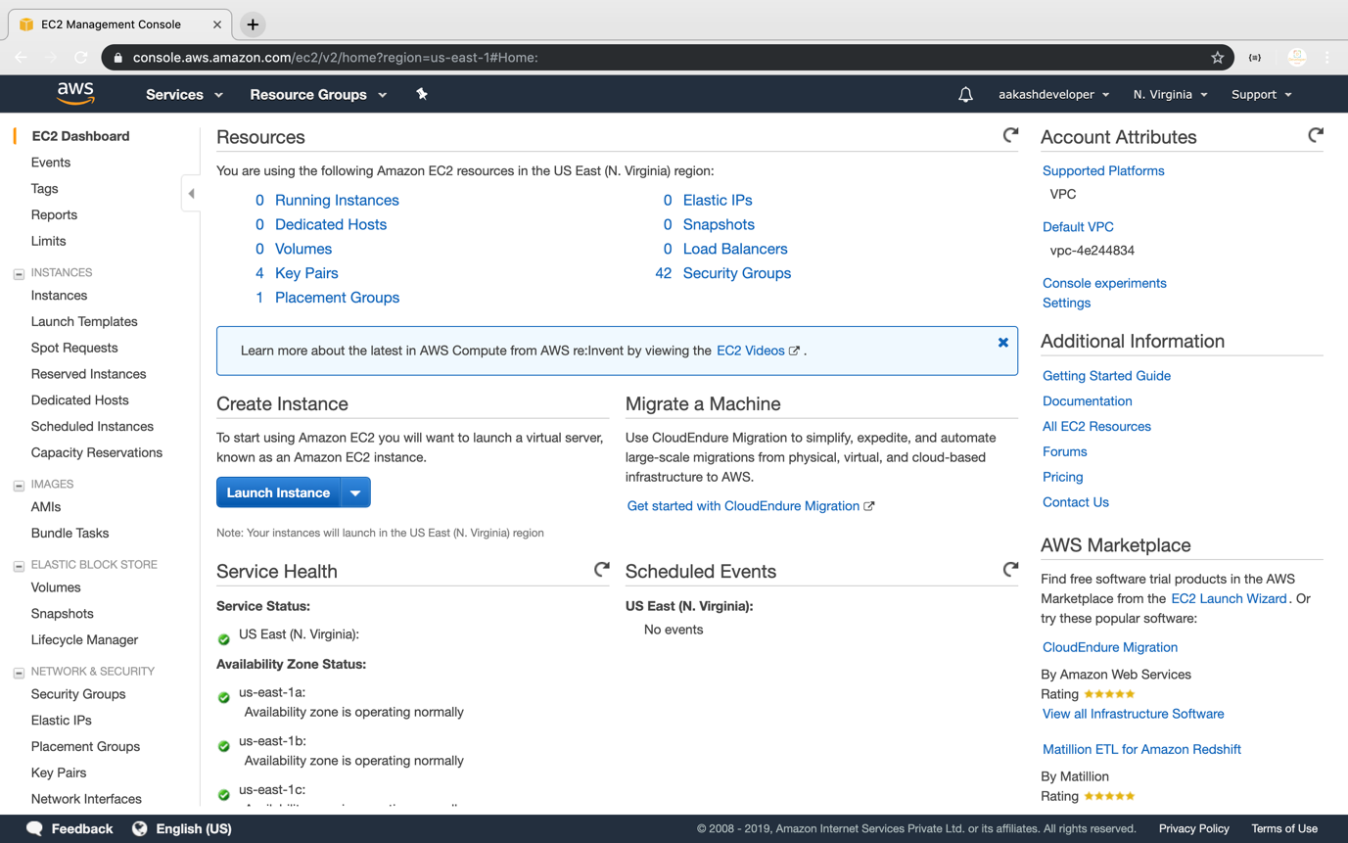

* Select the placement group

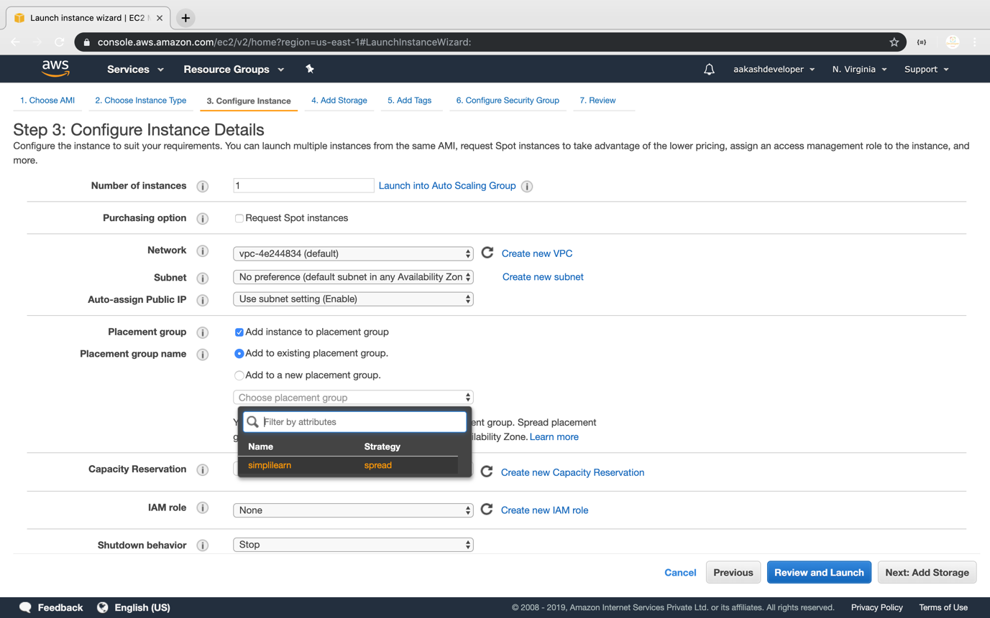

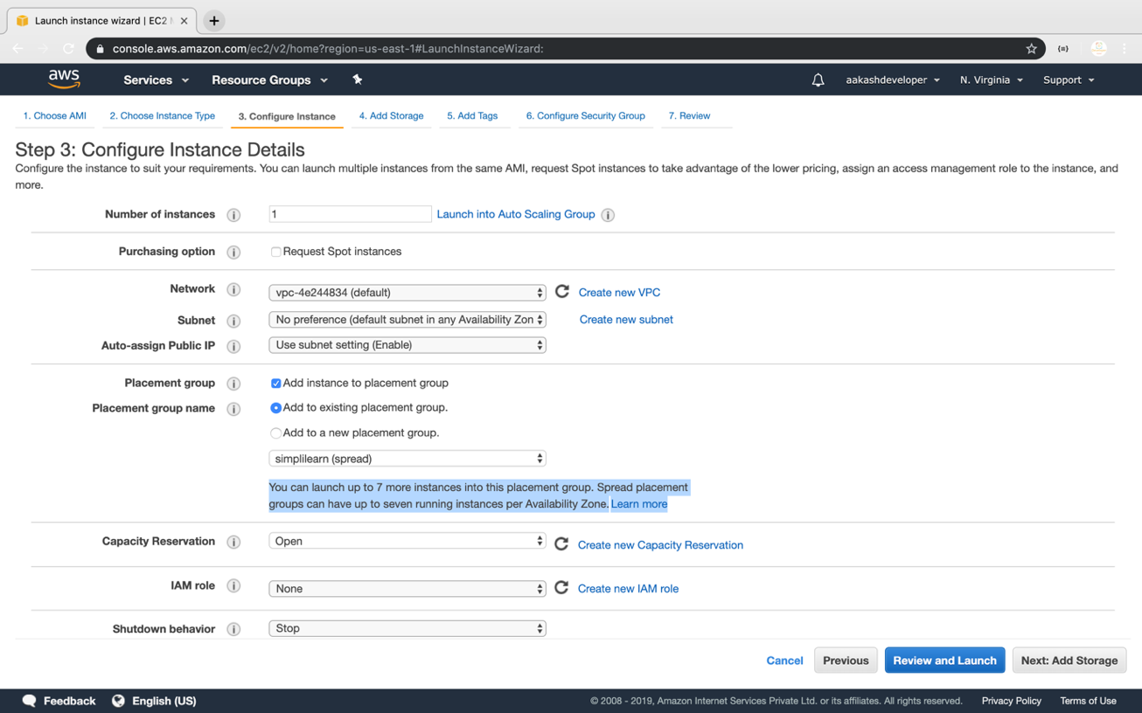

* Verify the placement group of the instance

